Kryuchkov  Vyacheslav  Alekseevich  Date of birth: 04.09.1969 | 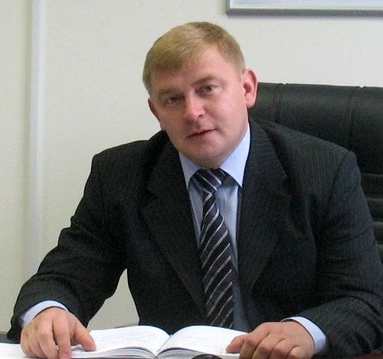 |  | Russia, Kemerovskaja region.  Novokusnetzk  Gorkovskaja street 4B-15  tel: (3843) 52-80-25,  mobile. +79039853872  e-mail: kryuchkov.rus@gmail.com

EDUCATION
1995  Qualification: Engineer: Speciality: “Electric drive and automation of industrial systems and machines” |  | Sibirian State Mining and Smelting Academy
1998  Qualification: Engineer: Speciality: «Mining electrical engineer» |  | Prokopjevskiy Mining and Engineering Colledge
Operational experience  «Kuzbass Mining Service»  «Hazemag & EPR GmbH»  Februar 2010 – July 2012 |  | General Director  Manager in Kuzbass (ASIATIC RUSSIA)
ООО «Deilmann-Haniel Rus»
June 2008 – January 2010
- Administrative and financial operation of business  - Compiling and approval of budget, supervision of budget perfomance  - Detection of a long-term strategy of commercial activity and financial plans of this organization, supervision of this processes  - Commodity market monitoring, extension of commodity market  - Operations with key clients(negotiations, execution of contracts, goods delivery supervision )  - Cooperation with representatives of foreign companies, administrative agents, city managers, company executives.  - Development of advertising campaigns, cooperation with mass media, preparation of presentations, participation in fairs.  - Execution of contracts with clients for procurement of equipment and after-sales service.  - Organization of after-sales service and repair works. |  | General Manager
- Management and maintenance of interrelations with controlling units.
- Development of a program: placement of funds and business plans.
- Transferring of non-core activities for outsourcing( bookkeeping, legal issues)
- Custom formalities clearance of delivered equipment.
- Cooperation with clients.
Public corporation «Juzhkuzbassugol»
Branch “Mine Erunakovskaja – VIII”  2006-2008  - Guidance of energy and mechanical service, mine construction, engineering, installation, setup, putting equipment into operation (underground and surface complexes)  - Support of functionality of equipment, support of safety operation, improvement of integrity and quality of production process.  - Improvement of technological processes.  - Innovation of broad automation of production processes, improvement of general efficiency of equipment functioning.  - Support of effective production and high level of technical security and labour protection.  - Cooperation with controlling units. |  | Plant engineer
Branch «Mine Esaulskaja»
2000-2006  - Guidance of energy and mechanical service of departments, operation of fixed installations, installation, setup, putting new equipment into operation.  - Innovation of broad automation of production processes, improvement of general efficiency of equipment functioning. |  | Senior mechanical engineer for fixed installations
Public corporation «Prokopjevskugol» Mine «Kirgaiskaja»  1998-2000  - Guidance of energy and mechanical service of departments, operation of fixed installations, installation, putting new equipment into operation. |  | Senior mechanic
1997-1998
- Guidance of department of mechanical service, service of machines and machinery. Operation, installation, setup, repair.  1992-1997 |  | Department mechanic
 |  | Mineworker -electrical fitter-department mechanic
- Way from a mineworker to department mechanic.
- Exploration of mine and mining, its machines and machinery not only by reading manuals and textbooks but also in practice.

PC skills
- skilled user

Additional information:
- marital status: married
- Children:daughter,21years old.
- Personal car: yes
- Driving license: category:В; С

