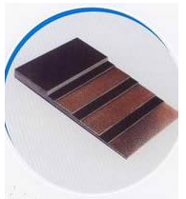
EP conveyor belt
Product characteristics:
Polyester conveyor belts, also called EP conveyor belts, whose tension resistant body is canvas woven by polyester in warp and polyamine in weft .The belts have the characteristics of low elongation in warp and good trough ability in weft, good water resistance, good wet strength, no mould it is suitable for medium, ling distance and heavy-load transportation of materials. Because of the high initial modulus of polyester, the belts can choose a relative low safety factor.
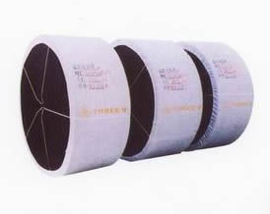
NN conveyor belt
Product characteristics:
Nylon is one of the belts quality synthetic fibers that the rubber industry use nowadays. The nylon canvas is woven by nylon fibers both in warp and in weft, it is the most widely used fabric in rubber industry, and its outstanding merits are its high abrasion resistance, high tensile strength and good fatigue resistance. Conveyor belt with nylon canvas inside have the characteristics of thin belt body, high tensile strength, good shock resistance, good trough ability, high adhesion between plies, splendid flexibility and ling working life. Nylon conveyor belts ate suitable for medium, long-distance and heavy-load transportation of materials, widely used in mining, metallurgical industry and architectural industry, ports and etc.
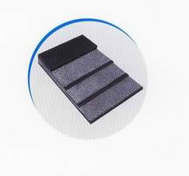
CC conveyor belt

Cotton canvas is woven by cotton fibers both in warp and in weft, its elongation is relatively low. It is good in mechanical fastening and adhesion with rubber. Conveyor belt has relatively small distortion under high temperature conditions. It is suitable for short-distance and light-load transportation of materials. Polyester cotton conveyor belt is the up graded product of cotton conveyor belt, and its tension resistant body is woven by polyester cotton fibers in warp and cotton fibers in weft. Its comprehensive physical and mechanical characteristics are obviously better than those of cotton conveyor belt, especially the belt body is thinner and lighter, the belt has better shock resistance and thus it has better performance and can reduce energy and material consumption for users .It is the idea selection for medium, short-distance and medium-load transportation of materials.

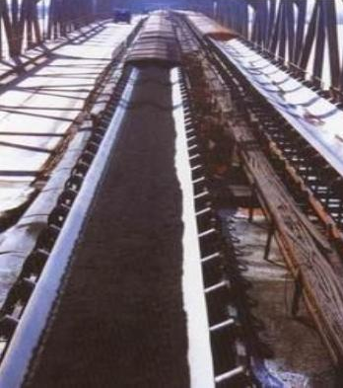
General conveyor belt

The product is made of cotton canvas, nylon canvas or EP canvas and made through the processes of calendaring, assembling, vulcanizing and etc. It is suitable for conveying various non-corrosive and thorn-less materials in blocks, in grains, or in powder, such as coal in block or in bales, under the condition of flammable or explosive environment in the coalmine.

HIGH TEMPERATURE RESISTANT CONVEYOR BELT

The belt carcass of this product is EP fabric of high modulus, low shrink, and high breaking tensile strength. Cover rubber of this product uses EPDM rubber or chloroprene rubber that has very good high temperature resistance. The belt is made of high temperature resistant materials, through assembling and vulcanizing with care.
The carcass of this product has very high adhesion after the special trestment of coating and shaping. Under normal working condition with the temperature below 180℃, the belt is low elongation and excellent anti-abrasion, it can also bear 250℃ high temperature for a short time. The belt is suitable for use in cement, metallurgical and steel industry.

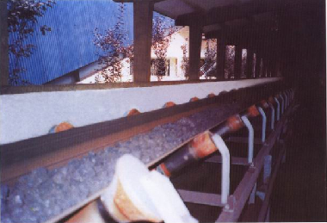
HEAT RESISTANT CONVEYOR BELT

The carcass of the product chooses cotton canvas or EP canvas as skeleton material. Cove rubber and buffer rubber is made from styrene-butadiene rubber or chloroprene rubber that has good heat resistance. The product can work properly under the temperature of 120℃ and is suitable for conveying materials under the temperature of 120℃ in industry of metallurgy, cement, steel, coking etc.
CHEMICAL RESISTANT CONVEYOR BELT

Product characteristics
Because the cotton-canvas, nylon-canvas or EP –canvas as the carcass, the belt has good elasticity, excellent trough ability, and low elongation. The rubber cover, which is made from chemical resistant materials, has fine anti-chemical corrosiveness and good physical properties.
Usage
It is suitable for conveying materials with chemical corrosiveness in chemical factory, chemical fertilizer factory, paper mill, mining industry etc.

OIL RESISTANCT CONVEYOR BELT
Product characteristics
The product is made of cotton canvas, nylon canvas or EP canvas and made through the processes of calendaring, assembling, vulcanizing etc. It is suitable for conveying oily materials.

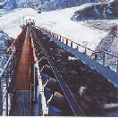
COLD RESISTANT CONVEYOR BELT
Product characteristics
The product selects cotton canvas, nylon canvas or EP canvas as carcass. Cover rubber selects a blend of NR and BR, which has the properties of high elasticity, shock resistance, cold resistance etc. It can work normally under the conditions of –40℃.

PATTERNED CONVEYOR BELT
Product characteristics:
Patterned conveyor belt is composed of belt carcass and pattern. The shape and height (depth) of pattern is subject to the material it conveyor and the angle of the machine.

ENDLESS CONVEYOR BELT
Product characteristics:
Endless conveyor belt is conveyor belt without joint. Its feature is that there is no joint in belt carcass, so that the belt shall not be shortened in service life due to early failure in the joints of the belt; the belt is flat in surface and even in tension, thus it runs smoothly with low elongation.

FOODSTUFF CONVEYOR BELT
Product characteristics:
The product selects cotton canvas, nylon canvas or EP canvas as carcass. The belt body has good elasticity and small distortion. Cover rubber of the belt is made of pure natural rubber and non-pollutive additives. The cover rubber is white or pale in color, non-pollutive, with no peculiar smell. The compounding formula of the product is reasonable, comforming to all hygienic indexed. The belt is mild in color, light and durable.

