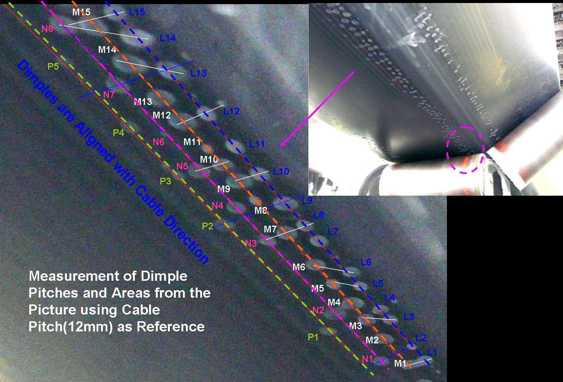
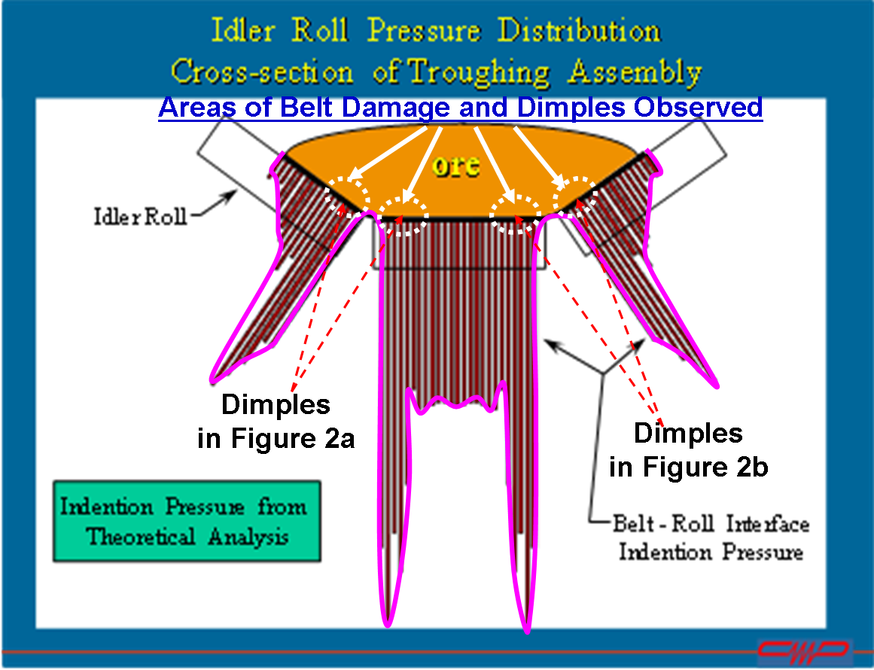

Cover Failure Due to Overstress of Belt Bottom Cover at Idler Junction (see insert photo).

