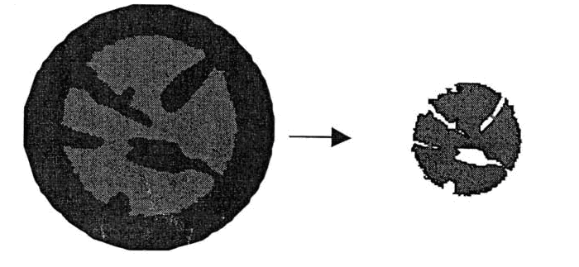

Fig 01, Particles model of shrinkage for the drying process of lignite (brown coal)

