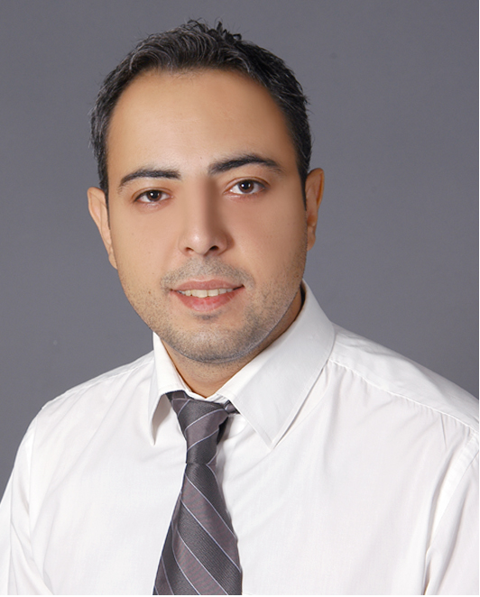
BILEN AVSAR 20.06.1978 AMSTERDAM
Mailing Address:Emek Mah.1 Nolu Sok.Yildiz Apt.No.7/7 Sehitkamil/Gaziantep Turkey
Tlf:+90 342 329 50 14
Mobile:+90 535 651 14 51
Mail:b.avsar27@hotmail.com
EDUCATION
1995-1997 Travel Speculator Foreign Country, LOI, Amsterdam,Holland
1995-1997 English language course, Schoevers, Amsterdam,Holland certificate gained
1991-1994 College Amsterdam MAVO; diploma gained.
Specialisation: Staff management
Relevant professions: staff & organisation
WORK EXPERIENCE
2006 Present Ritor Torba Sanayi ve Ticaret A.Ş :FIBC Sales Executive
1-Responsible for sale and customer satisfaction
2-Responsible for exporting of goods
3-Individual conversations with customers for their solutions
2006/2006 Karpedo Ice Cream Saloon Turkey:Owner
2002/2006 Westerveld Schoonmaker B.V.Holland: Staff manager
1-Responsible for staff an customers building cleaning results
1997/2001 Holliday Inn Hotel Turkey: Travel Speculator
1-Responsible for Hotel customers
2-Leading round of groups of 20-30 tourists
3-Organizing tours for site seeing (Historical places flora and fauna)
SKILSS AND INTERESTS
Turkish (Native)
English (Advanced)
Duch (Native)
Ms Office Applications(Word,Excel,Powerpoint)
Reading,cinema,puzzle,travelling,(Germany,Denmark,Finland,Spaine,Romania,Czech Republic, Portugal,France,
Austria,Belgium,Syria,Holland,Greece,)
NATIONALITY
Dutch/Turkish

